Case Study 3
BAN 673 – TIME SERIES ANALYTICS

Amisha Farhana Shaik – ac1425

The data set for case study #2 represents quarterly revenues (in $million) in Walmart from the first quarter of 2005 through the fourth quarter of 2024 (673_case2.csv). This quarterly data is collected from www.macrotrends.net/stocks/charts/WMT/walmart/revenue. The goal is to forecast Walmart’s quarterly revenue in the four quarters (Q1-Q4) of 2025-2026.

Create time series data set in R using the ts() function.

  - 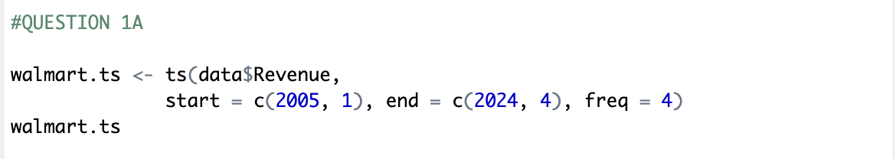

Develop data partition with the validation partition of 16 periods and the rest for the training partition.

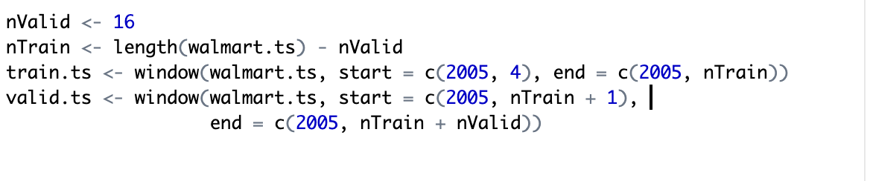

Questions
1. Identify time series predictability.
a. Using the AR(1) model for the historical data, Provide and explain the AR(1) model summary in your report. Explain if the Walmart revenue is predictable.

  - 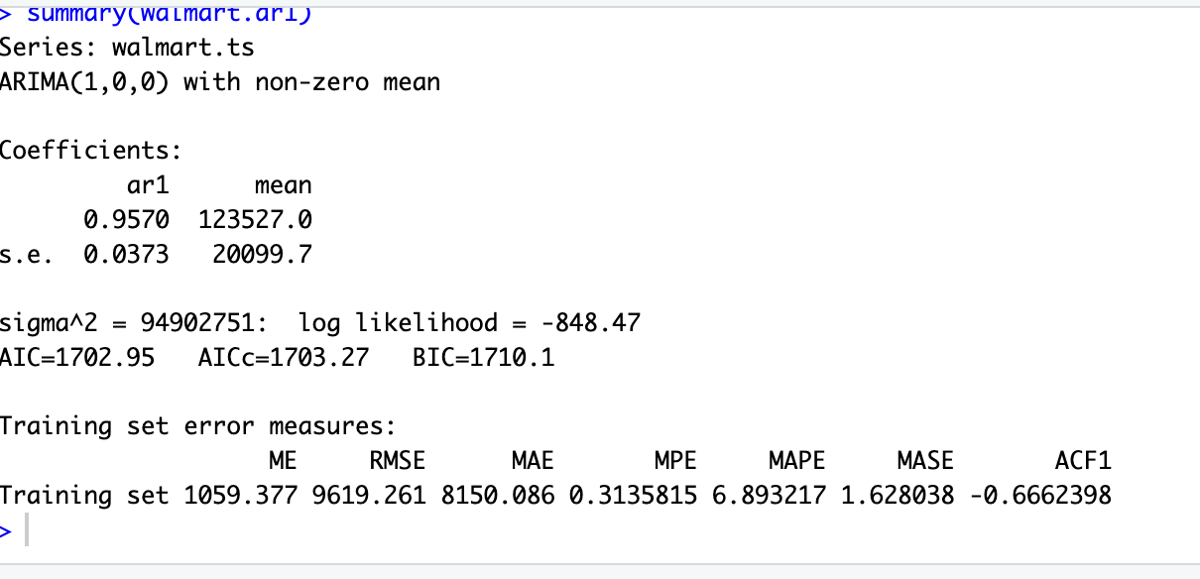

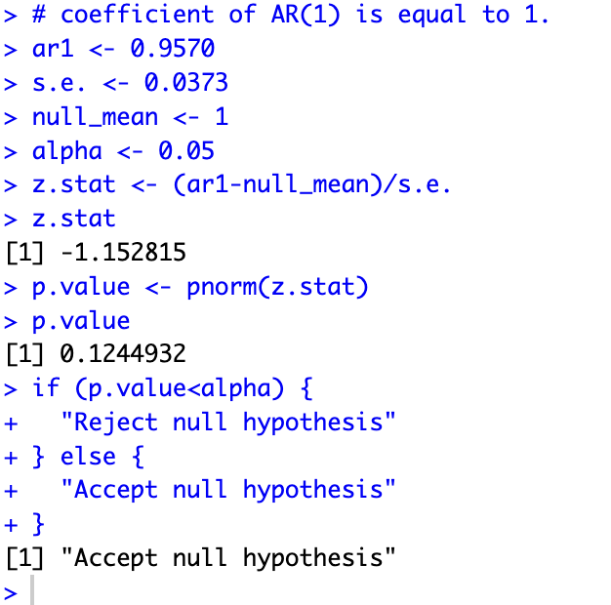
To assess the predictability of Walmart's quarterly revenue from 2005 to 2024, we applied an AR(1) model. The model uses the revenue from the previous quarter to predict the current quarter's revenue.
The model summary shows the AR(1) coefficient as 0.9570, which is close to 1, indicating that the revenue is random.
After the hypothesis test was conducted, even the p-value obtained was 0.1249, which is greater than the significance level of 0.05. As a result, we accept the null hypothesis, indicating there is no strong evidence to reject the random walk assumption. Hence according the null hypothesis testing the Walmart’s revenue is not predictable.
b.Using the first differencing (lag1) of the historical data and Acf() function, provide in the report the autocorrelation plot of the first differencing (lag1) with the maximum of 8 lags and explain if Walmart revenue is predictable.

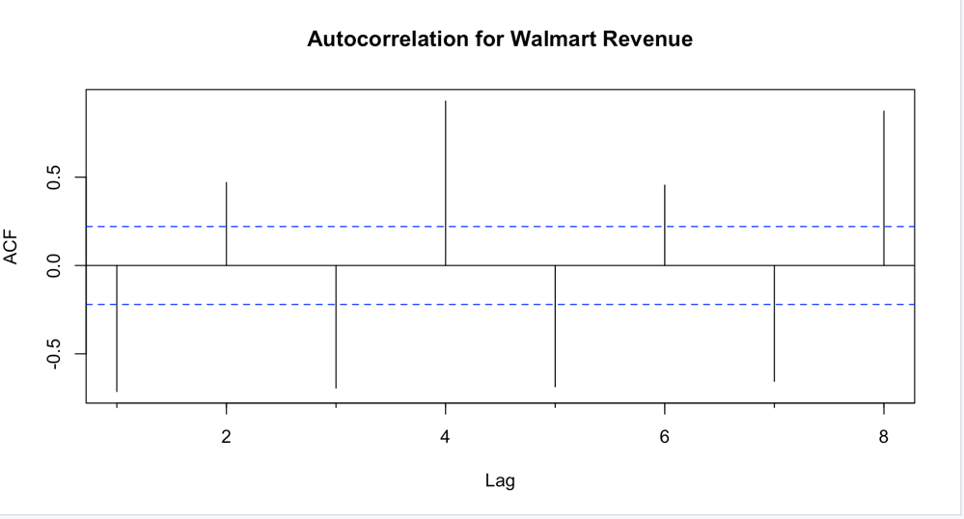
To further evaluate predictability, we applied first differencing (lag 1) to Walmart's historical revenue data and generated an autocorrelation plot which shows significant spikes at all lags which indicates that there are still dependencies in the revenue changes over time. The presence of these spikes confirm that the data is predictable, as it states that the data in fact is not random and has some strong auto correlation. This, result contradicts the earlier hypothesis test, that Walmart's revenue is not predictable as the differenced series shows autocorrelation.
2. Apply the two-level forecast with regression model and AR model for residuals.
a. For the training data set, use the tslm() function to develop a regression model with linear trend and seasonality. Forecast Walmart’s Revenue in the validation period with the forecast() function (use the associated R code from case #2). No explanation is required in your report.

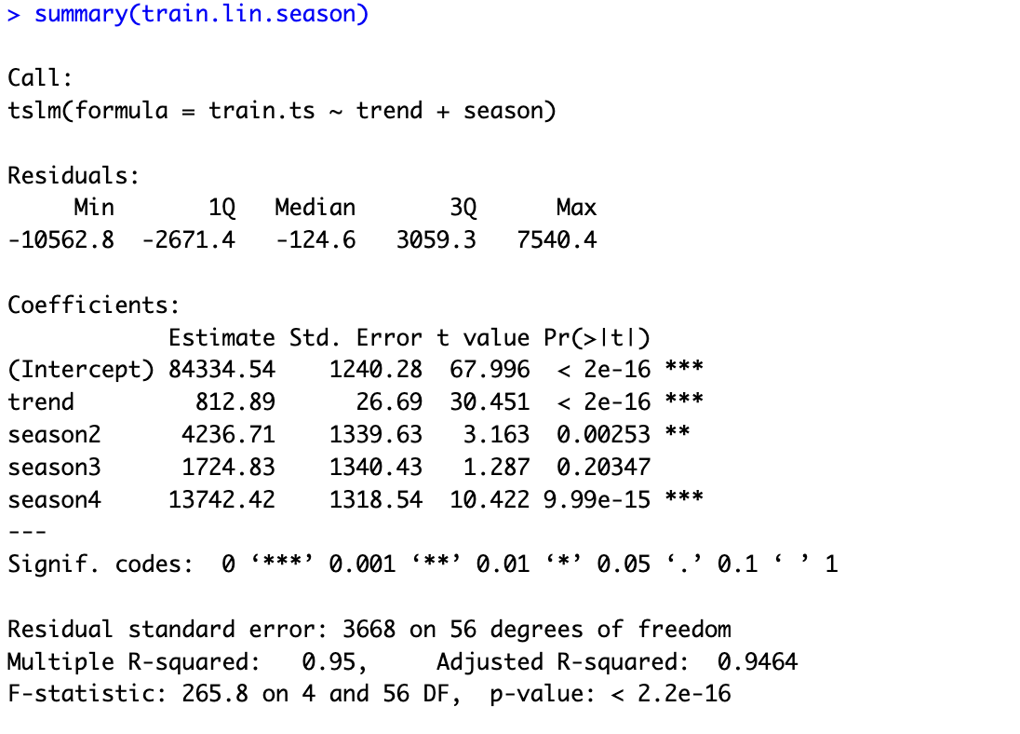
Forecast:

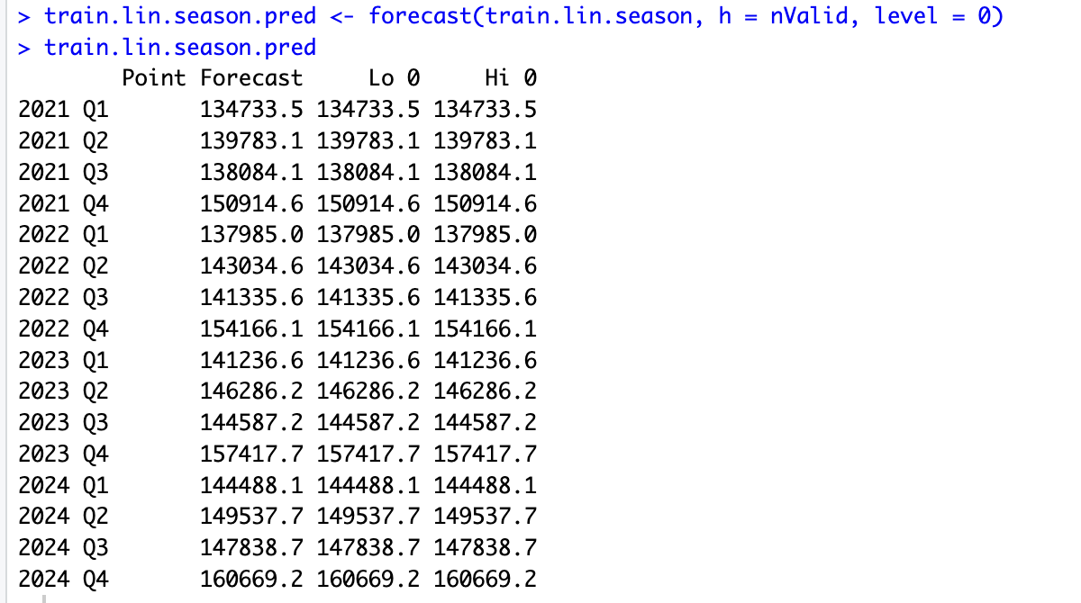
2b. Identify the regression model’s residuals for the training period and use the Acf() function with a maximum of 8 lags to identify autocorrelation for these residuals. Provide the autocorrelation plot in your report and explain if it would be a good idea to add to your forecast an AR model for residuals.

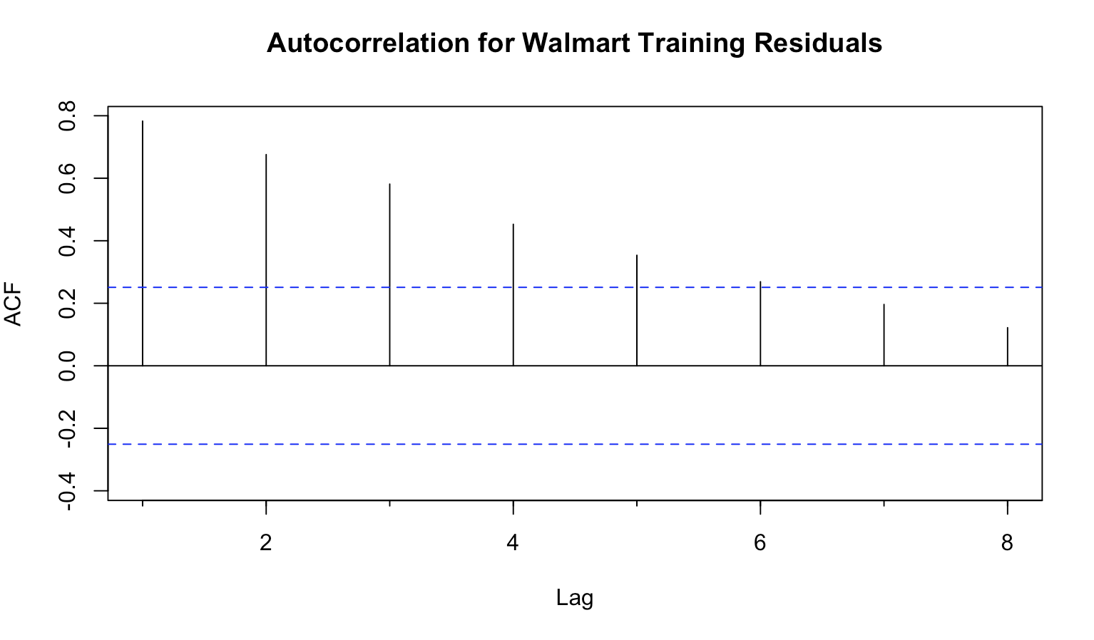
The plot displays significant spikes at lags 1, 2, 3, 4, 5 and 6, which extend beyond the blue threshold lines, indicating the presence of autocorrelation in the residuals. This suggests that the residuals are not purely random and still hold some structure that the original AR(1) model did not fully capture.
And hence it would be a good idea to add an AR model for the residuals to further refine the forecast. This additional AR model can help correct for the unexplained patterns, leading to more accurate predictions for Walmart's revenue in the future.

2c. Develop an AR(1) model for the regression residuals, present and explain the model and its equation in your report. Use the Acf() function for the residuals of the AR(1) model (residuals of residuals), present the autocorrelation chart, and explain it in your report.

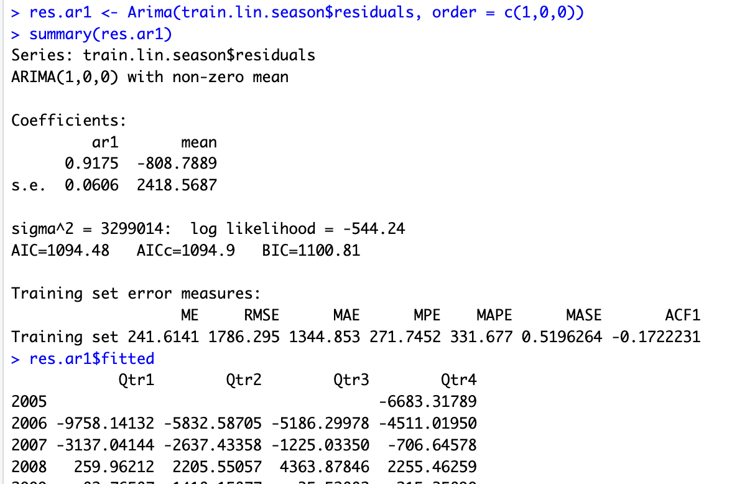

The AR(1) model predicts the current value of a series based on its immediate past value. It means it uses past observations as predictors.

Model Equation:
e_{t} = a + b₁e_{t-1} + e_{t}
e_{t} = -808.7889 + 0.9175 e_{t-1}
Where: e_{t} is the residual at time t. and e_{t-1} ​ is the residual at the previous time step.

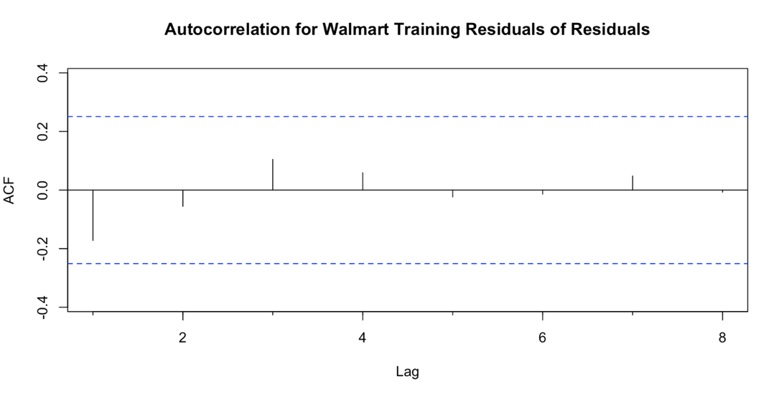
ACF plot for the residuals of the AR(1) model ("residuals of the residuals") shows no significant spikes beyond the confidence limits, indicating that the model effectively captured the correlation present in the original residuals.
This means the remaining noise after this step is mostly random, suggesting that the model has accounted for most of the predictable patterns in the residuals. And the data at this point is random walk.

2d. Create a two-level forecasting model (regression model with linear trend and seasonality + AR(1) model for residuals) for the validation period. Show in your report a table with the validation data, regression forecast for the validation data, AR(1) forecast for the validation data, and combined forecast for the validation period.
Forecast:

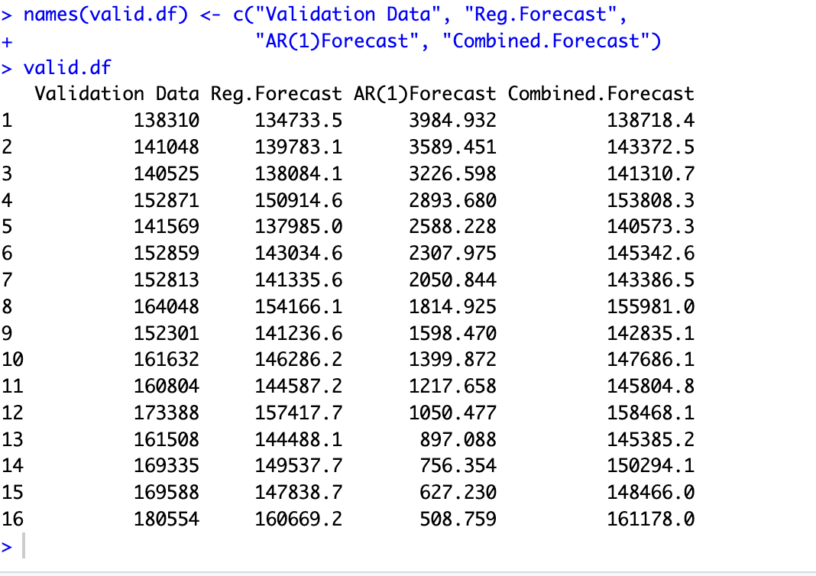

2e. Develop a two-level forecast (regression model with linear trend and seasonality and AR(1) model for residuals) for the entire data set. Provide in your report the autocorrelation chart for the AR(1) model’s residuals and explain it. Also provide a data table with the models’ _forecasts for Walmart revenue in Q1-Q4 of 2025-2026 (regression model, AR(1) for residuals, and two-level combined forecast).

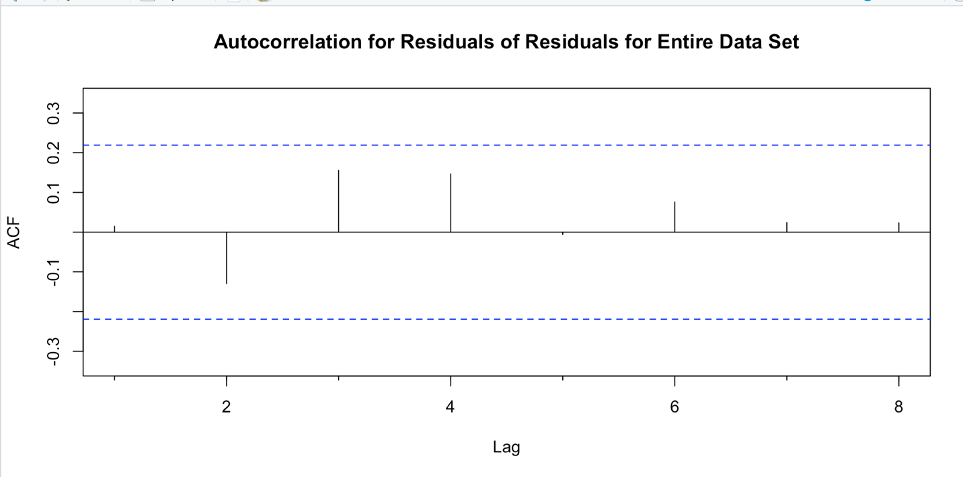

The ACF plot for the residuals on the validation period also shows no significant spikes. This confirms that there is minimal remaining autocorrelation, indicating that the model effectively captures the structure in Walmart's revenue data.

Forecast:
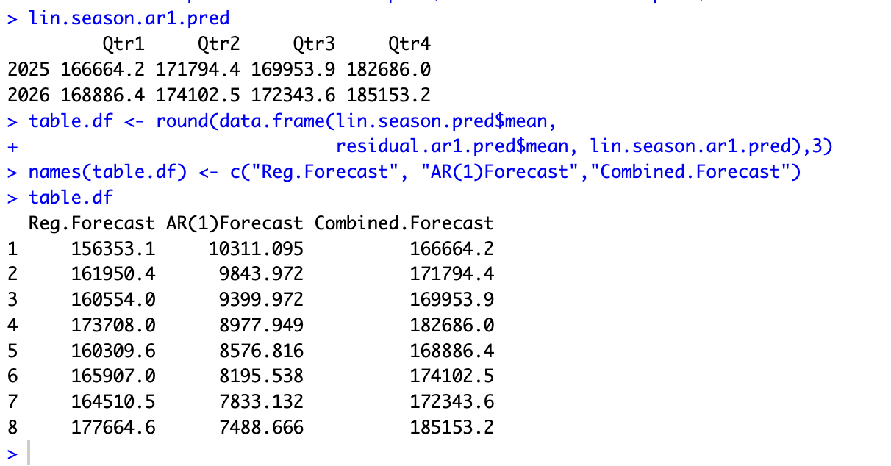

3. Use ARIMA Model and Compare Various Methods.
a. Use Arima() function to fit ARIMA(1,1,1)(1,1,1) model for the training data set. Insert in your report the summary of this ARIMA model, present and briefly explain the ARIMA model and its equation in your report. Using this model, forecast revenue for the validation period and present it in your report.

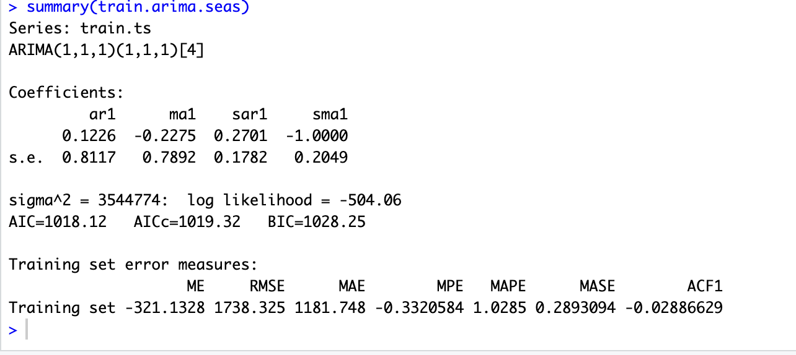
This is a Seasonal ARIMA model where we include additional seasonal terms (i.e., P, D and Q [m]) in the ARIMA (p d, q) model
• The first part, ARIMA (1,1,1), represents:
- p = 1: One lag for Auto Regressive (AR) terms
- d = 1: One differencing step to remove linear trend
- q = 1: One lag for the Moving Average for error lags
• The seasonal part, (1,1,1) [4], represents:
- P = 1: One seasonal lag for AR
- D = 1: One seasonal differencing
- Q = 1: One seasonal lag for MA
- M = [4]: Specifies that the seasonality repeats every 4 quarters (one year)

General Model Equation is:
y_{t} - y_{t-1} = b₀ + b₁(y_{t-1} - y_{t-2}) + b₂(y_{t-2} - y_{t-3}) + e_{t} + q₁ e_{t-1} + q₂ e_{t-2}
y_{t} - y_{t-1} = 0.1226 (y_{t-1} -y_{t-2}) - 0.2275 e_{t-1} + 0.2701(y_{t-1} -y_{t-5}) - 1ρ_{t-1}
Here we do not have intercept, drift i.e., b₀ because this is a difference model.
The ARIMA(1,1,1)(1,1,1)[4] model produced the following accuracy metrics:
- RMSE (Root Mean Square Error): 1738.325
- MAPE (Mean Absolute Percentage Error): 1.0285
These values indicate that the model's predictions, on average, are approximately 1.03% off from the actual values. The lower RMSE suggests the model is effectively capturing the revenue variations across the quarters with relatively low error margins.
Forecast:
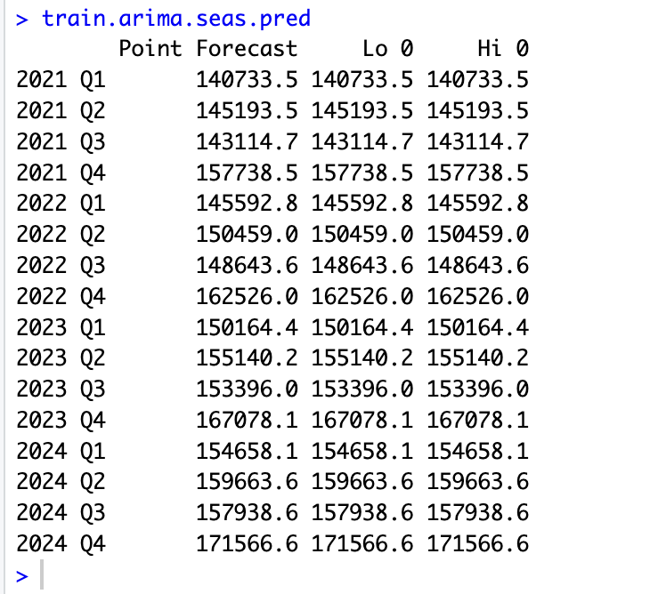

3b. Use the auto.arima() function to develop an ARIMA model using the training data set. Insert in your report the summary of this ARIMA model, present and explain the ARIMA model and its equation in your report. Use this model to forecast revenue in the validation period and present this forecast in your report.

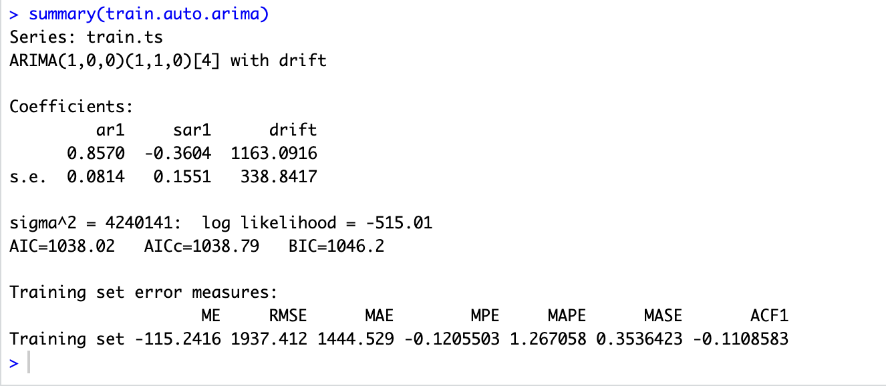
auto.arima() function in R is used to identify ARIMA model automatically and also its respective (p, d, q)(P, D, Q) parameters

General Model Equation is:
y_{t} - y_{t-1} = b₀ + b₁(y_{t-1} - y_{t-2}) + b₂(y_{t-2} - y_{t-3}) + e_{t} + q₁ e_{t-1} + q₂ e_{t-2}
y_{t} - y_{t-1} = 1163.0916 + 0.8570 (y_{t-1} -y_{t-2}) + 0.2701(y_{t-1} -y_{t-5}) - 1ρ_{t-1}
Here we have intercept, drift i.e., b₀ ₌ 1163.09 because this is a difference model.
The ARIMA(1,0,0)(1,1,0)[4] with Drift model generated the following accuracy metrics:
- RMSE (Root Mean Square Error): 1937.412
- MAPE (Mean Absolute Percentage Error): 1.2671
Compared to the ARIMA(1,1,1)(1,1,1)[4] model, this model has: A higher RMSE indicating slightly larger prediction errors and a higher MAPE suggesting the model is less accurate in capturing the true revenue values of Walmart.
But we have to keep in mind that these accuracy metrics are on training data. To actually finalize the best model we need to test in on validation set and then finally run it on entire dataset.
Forecast:
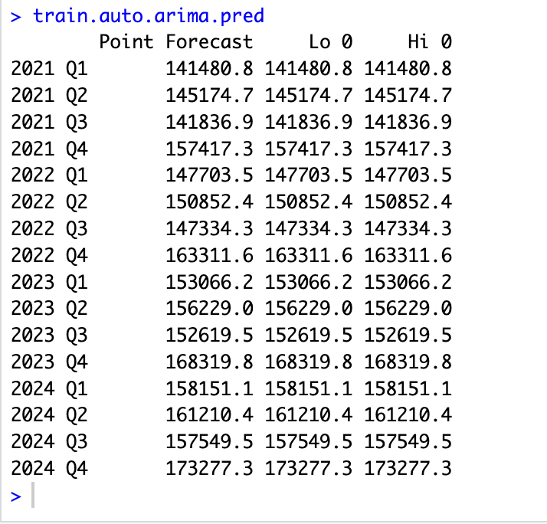

3c. Apply the accuracy() function to compare performance measures of the two ARIMA models in 3a and 3b. Present the accuracy measures in your report, compare them and identify, using MAPE and RMSE, the best ARIMA model to apply.

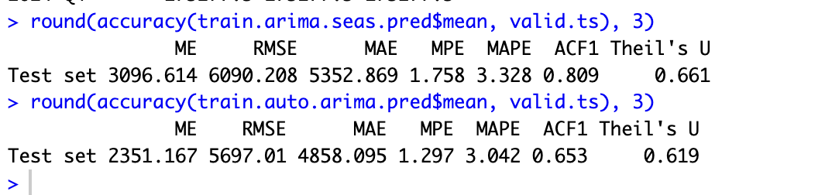

Although the ARIMA(1,1,1)(1,1,1)[4] model performed better on the training set, the ARIMA(1,0,0)(1,1,0)[4] with Drift model actually performed better on the validation set. It has lower RMSE and lower MAPE, indicating more accurate predictions on unseen data. So the Auto Arima model is the best model to apply based off the metrics on validation set.
3d. Use two ARIMA models from 3a and 3b for the entire data set. Present Model’s summaries in your report. Use these ARIMA models to forecast Walmart revenue in Q1-Q4 of 2025-2026 and present these forecasts in your report.

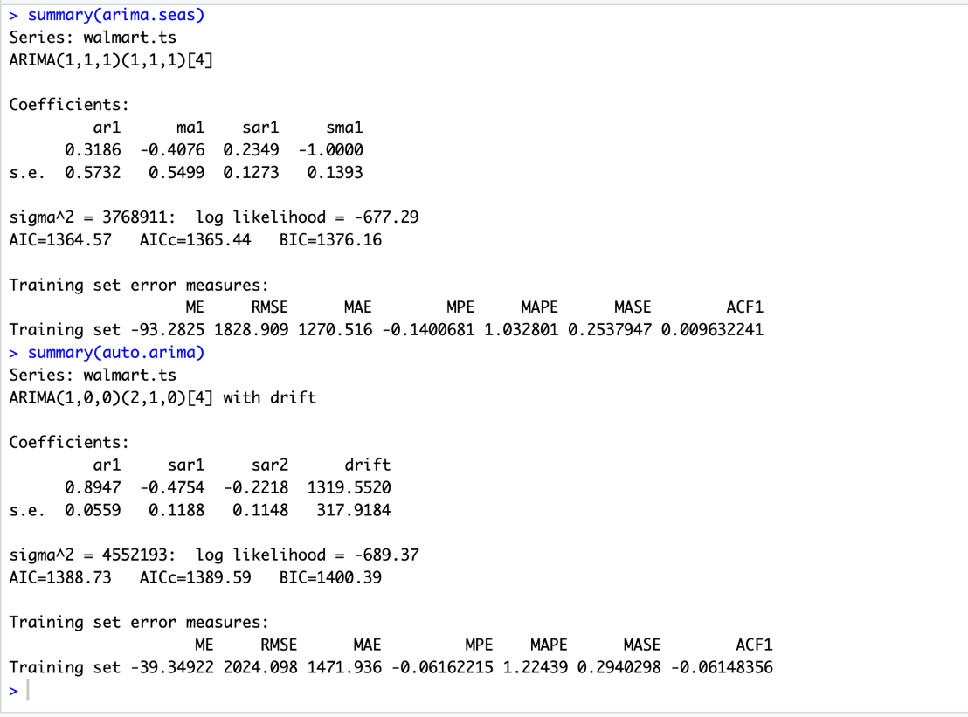

Forecast:
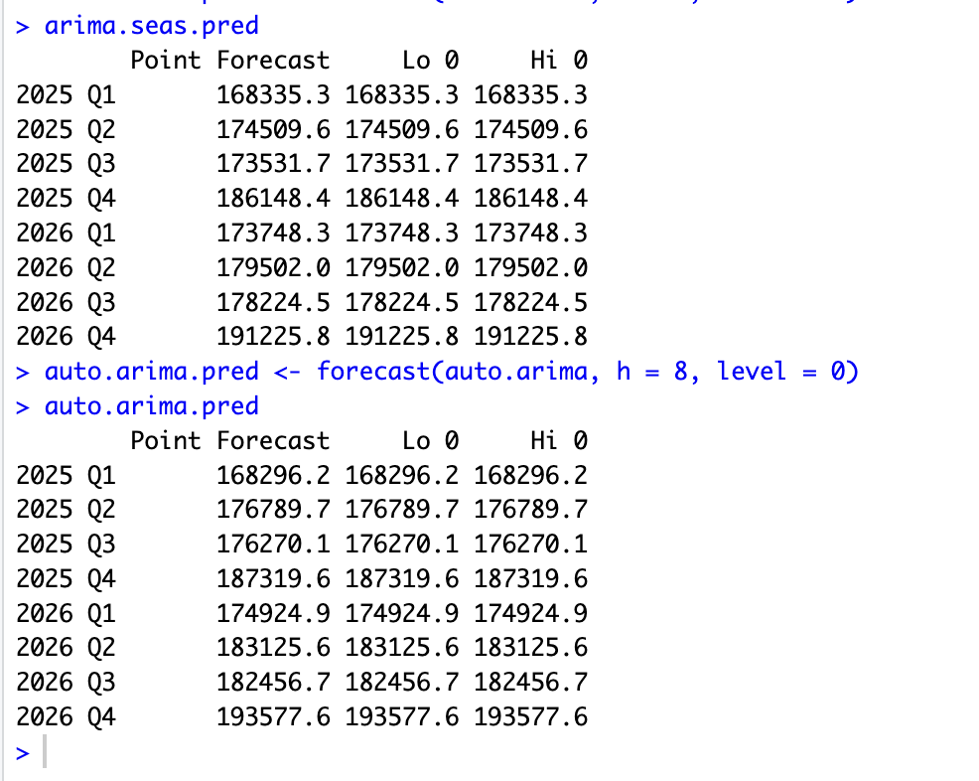

3e. Apply the accuracy() function to compare performance measures of the following forecasting models for the entire data set: (1) regression model with linear trend and seasonality; (2) two-level model (with AR(1) model for residuals); (3) ARIMA(1,1,1)(1,1,1) model; (4) auto ARIMA model; and (5) seasonal naïve forecast for the entire data set. Present the accuracy measures in your report, compare them, and identify, using MAPE and RMSE, the best model to use for forecasting revenue in Q1-Q4 of 2025-2026.

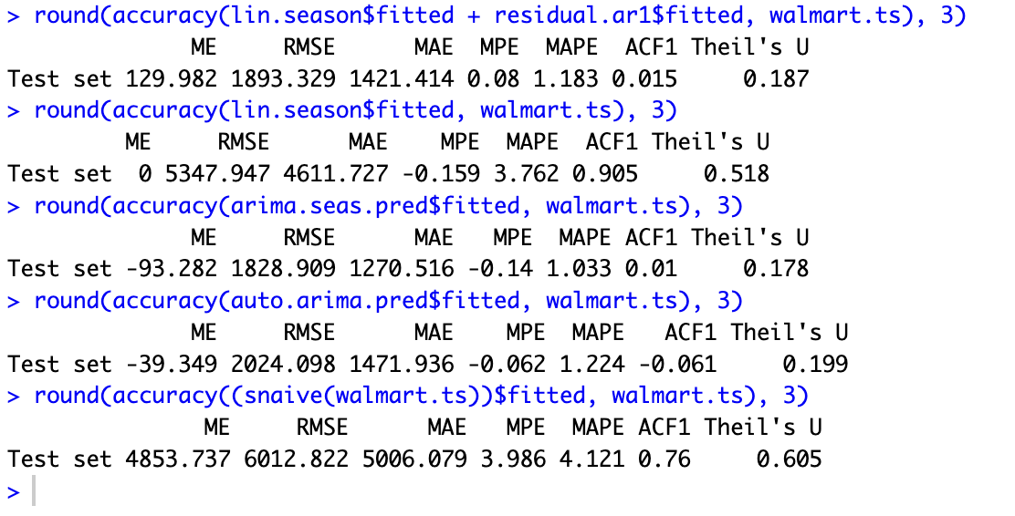

Observations:
- The Two-Level Model and the ARIMA(1,1,1)(1,1,1) have the lowest RMSE and lowest MAPE, making them the most accurate on the entire dataset.
- The Regression Model is close but slightly higher in both RMSE and MAPE compared to the two-level approach.
- The Auto ARIMA model has higher error rates, while the Seasonal Naive forecast performed the worst, suggesting it is not suitable for capturing the complex patterns in Walmart's revenue.
- But the fact that our other complex models performed better than Seasonal Naïve is a good sign that we were able to incorporate more components through these model approaches.

Best Model for Forecasting 2025 Revenue:
Based on RMSE and MAPE, the ARIMA(1,1,1)(1,1,1) is the best choices for forecasting Walmart's revenue for Q1-Q4 of 2025 as it has the lowest RMSE and MAPE.
Infact, Two-Level Model can also be used as the best model as it’s accuracy metrics are also very close. Both models capture the seasonal and trend elements effectively while minimizing errors.

